Figure S1: FTIR-derived spectral abundance for the range of wavelengths and their principal components (PCs) from a principal component analysis of all samples were used to identify the peaks that showed distinct variation across the treatments. The following wavelengths were used in our analysis of changes in plant litter chemistry:

970-1015: Carbohydrates, ester bonds
1015-1080: Carbohydrates, glycosidic bond
1100-1160: Carbohydrates, ester bonds
1160-1230: Carbohydrates, C-O stretching
1450-1475: Alkane (C-H bending)
1545-1600: Proteins (amide 2, N-H bending)
1620-1645: Proteins (amide 1, N-H bending)
1700-1750: Lipids (aldehyde or esters with C=O stretching)

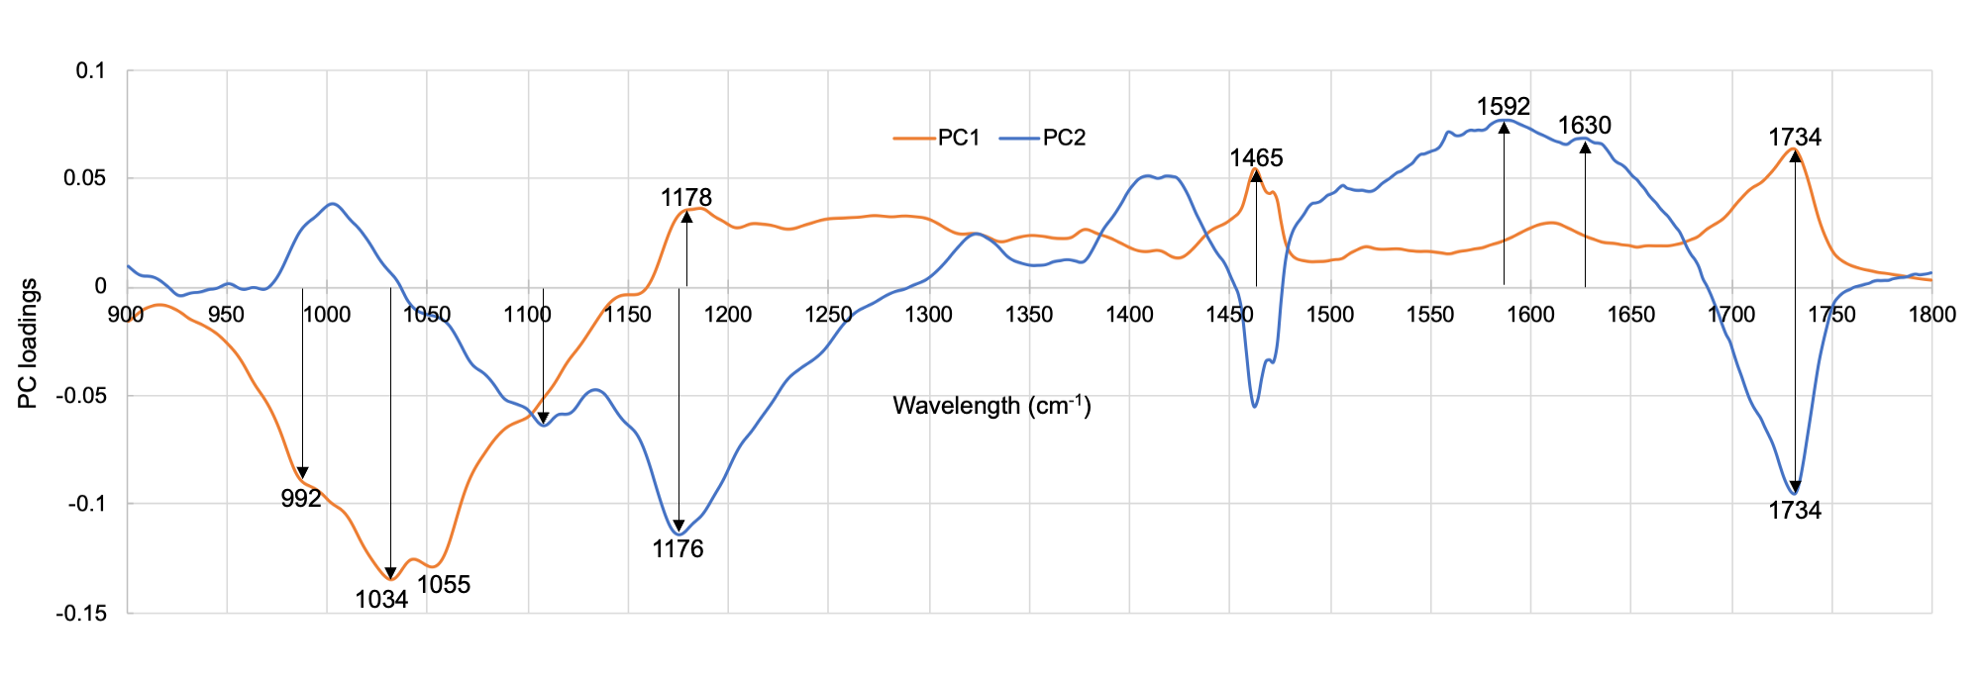
Table S1. Effects of vegetation communities and precipitation treatments on enzyme Vmax, FTIR litter chemistry, and CAZyme gene abundance. Cohen’s D is calculated for significant main effects (either vegetation or precipitation) while significant vegetation and precipitation interactions are denoted with an asterisk. Insignificant results have empty cells. P-values are denoted for significant main effects and their interactions as asterisks * p < 0.05, ** p < 0.01, *** p < 0.001, with main effects using p-values from Tukey’s pairwise comparisons and interactions using p-values from mixed effect models. P = Precipitation treatment. V = Vegetation community.
+ Not significant under mixed effect modeling but had groups that were statistically significantly different (p < 0.01) under Tukey’s pairwise comparisons
 |  | Transformation | V | P | V x P
Enzyme Vmax | AG | log10
Enzyme Vmax | AP | log10
Enzyme Vmax | BG | reciprocal
Enzyme Vmax | BX | log10
Enzyme Vmax | CBH | log10 | 2.9328***
Enzyme Vmax | LAP | reciprocal
Enzyme Vmax | NAG | log10 | 2.4994***
FTIR band | 1015 - 970 cm⁻¹ | reciprocal | 2.0241***
FTIR band | 1080 - 1015 cm⁻¹ |  | 2.7182*** |  | *
FTIR band | 1160 - 1100 cm⁻¹ |  | 1.2610*** | 0.7146** | *
FTIR band | 1230 - 1160 cm⁻¹ |  | 2.0109***
FTIR band | 1475 - 1450 cm⁻¹ | reciprocal | 2.0938***
FTIR band | 1600 - 1545 cm⁻¹ |  |  | 0.9759*** | +
FTIR band | 1645 - 1620 cm⁻¹ |  |  | 0.8644***
FTIR band | 1750 - 1700 cm⁻¹ |  | 3.4802***
Putative substrate CAZyme gene abundance | Cellulose
Putative substrate CAZyme gene abundance | Chitin |  | 0.8150**
Putative substrate CAZyme gene abundance | Hemicellulose |  | 1.6573***
Putative substrate CAZyme gene abundance | Lignin |  | 1.0556*** | 0.7647**
Putative substrate CAZyme gene abundance | Oligosaccharides | reciprocal | 1.1331***
Putative substrate CAZyme gene abundance | Peptidoglycan
Putative substrate CAZyme gene abundance | Polysaccharides
Putative substrate CAZyme gene abundance | Starch |  | 1.3334***
Community composition | F:B | reciprocal
Community composition | Taxonomic diversity |  | 0.9080*** |  | +

